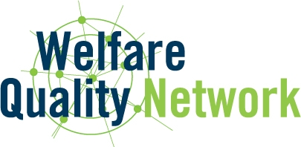

Procedure and requirements for the acceptance of new partners in the Welfare Quality Network

Introduction
The Welfare Quality Network is a collaborative effort of a large group of former partners of the Welfare Quality® project. The Network focuses on scientific exchange and activities designed to contribute to the further development of the Welfare Quality® animal welfare assessment systems. The Welfare Quality Network also aims to provide relevant knowledge and services to support actors in animal production chains who would like to implement or use the Welfare Quality® animal welfare assessment systems.
The results of the Welfare Quality® project have a clear impact on research in the area of animal welfare and its assessment. Such research is obviously not just carried out by former Welfare Quality® partners so to relate to and take account of the whole spectrum of related studies and results, the current partners agreed to invite other institutions that work in this area to join the Network.
This document describes the procedures and requirements for the acceptance of new partners in the Welfare Quality Network.

Relevant research and expertise and impartiality
New partners must demonstrate high competence in animal welfare (e.g. publication record, research impact, educational performance, evidence of networking and leadership). They should be involved in the development of knowledge or methodologies relevant for the further development of the Welfare Quality® approach.
New partners must demonstrate impartiality. They should also have no conflicts of interest but should demonstrate awareness of industry problems and requirements.

Collaboration agreement
New partners need to agree to and sign the existing Welfare Quality Network collaboration agreement and its explanatory addendum.

Fees

New partners are requested to pay an entry fee (€ 2,500) plus the fee of the entry year.

Procedure
Institutions who want to become a partner of the Welfare Quality Network must complete the entry request (ANNEX 1) and submit this to the Coordinator of the Welfare Quality Network. The Management Team will then advise the General Assembly regarding acceptance. The General Assembly will take the final decision.

ANNEX 1

Request to become partner in the Welfare Quality Network

Applicant (organisation, name(s) of scientists involved)

Competence in animal welfare and welfare assessment

Expected contribution to the further development of the Welfare Quality® approach

Statement on impartiality

Literature references

